Kemkvitto A simple app for increased service level in retail dry-cleaning

How it works now

- Customer hands over clothes
- The washer takes clothes
- Washer writes on the receipt pad
- Washers tear off half the receipt and put the number tag on the clothes (or classic carbon copy)
- Customer receives the other half of the receipt
- Clothes are washed and kept in order using the number tag
- The customer comes back when the clothes are ready
- Customer hand over the receipt (if he has not lost it) and get his clothes back

How it works with the added digital service

- Customer hands over clothes
- The washer takes clothes
- Washer writes on the receipt pad
- Washer asks customer: “would you like your receipt sent to your email?”
- Washers turn to their iPad
- Click New receipt (if not already open in new-receipt-view)
- First: Quick check that it has same number on the page as on the receipt pad (it should)
- Then: Check the boxes for the same service(s) as on the receipt pad
- Then: Put in the same date for delivery as written on the receipt pad
- Turn it over to the customer
- Customer write in email
- Back to the washer: press “Done”
- Should beep in the customer's phone or email at once.
- Message with the information has been received.
- Everything else is done just as usual (customer can take paper receipt too if they like)
- On the date, the customer receives a ping in the mail
- Customer goes to pick up laundry, with or without paper receipt because it is in his email

Functionality for the washer

Tier 1 (only one tier for now): To send the receipt/info to the customer email. Functionality to add prices to items where the washer can enter their own prices and have it added together automatically (not as a cash register system, just a simple calculation of sums, mimicking what is often written on the pad)
Access to list where receipt number, email & day for pickup is displayed, (sorted under day for pickup) So that if there is a delay, if the washer wish to do so, they can change the date and send a message to the customer about the delay. This should update the reminder email sent to customer.

Send email reminder ping on the specified day (no automatic check if laundry is really finished, just remind that the specified date has arrived, if there is some delay then that is what it is, or maybe the washer used the message function, in which case the reminder email is updated and sent at the new, later date)

For the thing to work + some thoughts

- A url where washers log in (I’m thinking www.kemkvitto.se) or maybe it is an app in the app store….
- A size-of-screen/device adaptable web page, or app, that presents the mimicked image of the classic paper receipt on screen.
- Should be possible for washer to pick colour of receipt image out of 11 colours that they can pick for their paper receipt pad (so they can keep the match between analog and digital for maximum stringency)
- A credit card payment thing connected to the service, like stripe for the washers to pay for the service.
- Possibility to test for free for a period (two weeks or a month or something)
- Possibility to A/B-test whether it works best to have the washers choose test-for-free-option, put in credit card info, then test for free and after that the service start to charge, OR, if it works better to just let them start the service with no strings at all and after the trial period THEN have them put in the credit card info...
- An email sending service hooked up to the service.
- Have a part of the database be visible to the washer when logged in, so they can browse or search for receipts there by email. (That way, even if a customer looses the paper receipt AND phone AND gets shut out of their personal email all at the same time, the washer can still find the receipt)
- A database to collect email addresses (but no names = No GDPR) for sending receipts (user cannot opt-out of this database)
- Maybe….(just a thought: A mirror of the database, that the user CAN opt-out of, for the washer to send offers and/or other info of a commercial nature to the clients. The database taking note of how many times a customer has been in the store/washer, so the washer can choose to send a message only to returning clients (or the opposite, exclude returning clients from a message)
- Clever fields on the receipt screen that make the correct number or email pop up after filling in a few digits/letters. If email is johan.anderson@gmail.com then if johan comes in to drop off ten shirts johan only has to write j, o, h, a, and his email should pop up as an option.

After feedback January 2023

- The washers own receipt list that he can see when logged in
--- Just a list view, need not be very pretty, but would be great if the washer could choose to sort it by either date or by receipt number. I was thinking the list could save maybe 500 receipts and make it an add-on/tier to save 10x that (just off the top of my head).

- Reminder-email
--- Is it possible to have the reminder not only send the exact same info again (wich would of course be the easiest way, I suppose) but to add a line: "Your dry-cleaning should be ready for pick up today" at the top of the email?

Swedish: Idag borde din kemtvätt vara klar. Här är ditt kvitto:
English: Your dry-cleaning should be ready today. Here’s your receipt:

The word “Should” is important, since this is just info based on the date on the receipt, not the actual delivery of the clothes. Just as it would work with paper receipt.

- 5 shirt/10 shirt separate in price list and as checkbox (or some clever thing we might figure out)
--- Walking in to these places it is obvious that 5 shirts or 10 shirts are the bulk of the business. I think to add special buttons/checkboxes in slightly separate color or shape just saying "5" & "10" to make it extra very easy to do such a receipt. And the "5" and "10" need their own prices in the price list because it is a special deal, it's never just 1+1+1+1+1=5.

- Security certificate
--- Or what it is that is needed to make it possible to reach the website without having a red flag going up. Or if its an app in app store, whatever is needed.

- Larger buttons and fields
--- A bit of a size increase is necessary. Some people are clumsy with the touchscreens and any small error will create a bothersome situation for both the end client and the washer. Best to try to make it all a bit larger so that a child could use it. It is not the coolest design but user speed & precision comes first on this one.

- The email subject line
Should say “YoIs it possible to have the subject line vary with the washer? So it could contain the washers name...? I bet the washers would like that!

- A reset button for the receipt number order, by the receipt number field.
I noticed while testing at my washer that if no number is put in manually, at all, just blank field, then it will follow the sequence. My guy started by giving me number 1001 and my next receipt was 1002 when he left the field blank.
But if a manual override is done, and for example 7865 is put in for whatever reason, meaning they took out a special note for a rare item or something, then the sequence will resume with 1003 on the next receipt if field is left blank.
My washer liked it, BUT, there must be a easy accessible reset button for the sequence so the washer can start over fresh when they start on a new set of number-notes/receipt pad that they pin to the clothes.
One more thing: Since we have the sequence thing going and our washer liked it; could we make the next number in the sequence visible so that if it checks out, its all good and washer does not even have to touch it, just a quick ocular confirmation that it is the same number as the paper note pad will do. What is needed then is a reset option and a ?-mark drop down menu with some extra explaining how to keep the sequence in control and that it can be overridden, but that it will continue as before after the one override. If it is not reset completely of course.

Copy to explain the sequencing tool:
Provided here is a specially designed receipt sequencing tool that keeps the receipt number order for you after you enter the first receipt number. But, you can override the sequence at any time, while still maintaining the number order, which will resume the next time you don't choose to fill in anything else. If you choose to reset the sequence the order starts over at the number you choose fill in.
Round 2

Hex codes for color choices
Colors are:
Green
Blue
Orange
Blue/Green
Brown
Yellow
Purple
Pink
Red
Grey

82C58A
6BA6D2
EBA17D
3CB4A9
BA906C
ECE080
ABA2DA
EFC6D2
E5919D
ACA6A2

I think the color can have an impact on the idea, because that is a personal choice, out of a fairly small selection (no paradox of choice), that the washer made at some point. It will be a nice feature that you can get that strigency.

Note: It is possible bc of the differences in the display of color in print vs screen that the saturation has to be adjusted later on but I’d like to test with these.

One more thought on color; could the choice of color flood the backdrop with that color, something along the lines of what I have sloppily done in the screengrab here:

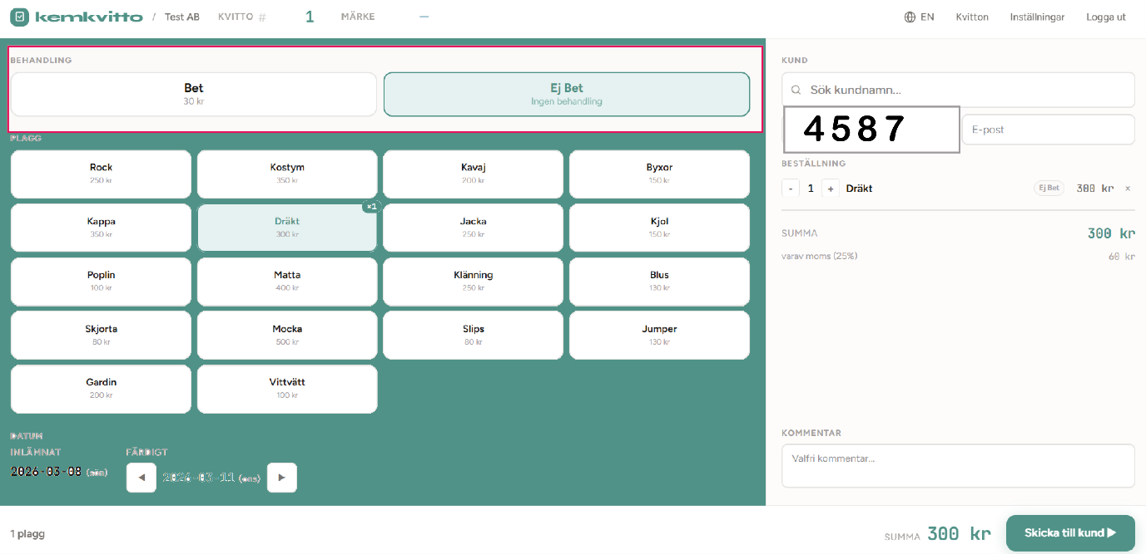

The receipt number field ought to move in together with the customer critical info on the right. Somewhere around where it could replace Telephone, don’t need that one just now anyway. It should have a pretty prominent place, maybe a slightly thicker frame and a off-style larger font to separate it from the rest, Like on the paper pad, signify its importance and act as a “remember” to the washer to keep an eye on it.

I go into it a bit in the perhaps unnecessary elaborate explanation here.
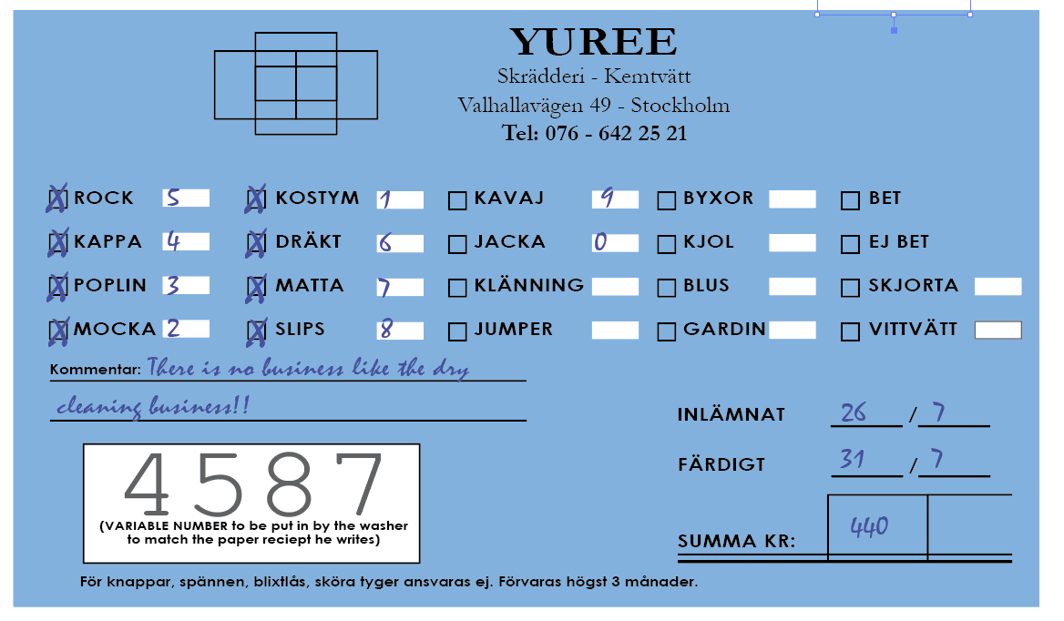

From my looking at all kinds of these receipts they always have a 4-digit number, sequentially printed on every note in the receipt pad.

It was a hell of a thing to translate from paper to screen, and its still not perfect; or rather you can’t make it perfect. Too many variables combined with some must haves.

What if all is well at the dry cleaners and the first three customers of the day want an email receipt, great, the washer rips note after note three times, and the sequencing is kept up by Kemkvitto. It started the morning at 4587, went to 4588 and 4589.

But customer four says “Nah, I’m good with the note, cheers”

That was 4590 going out the door. Now the pad will say 4591 on the next one, but Kemkvitto will still be at 4590.

Next customer five pops in, he knows this, wants it in his email. No need for a note. The washer will still need to put note 4591 on the garments and get the customer his email-receipt. Easy, sure, but he must not forget to update manually to 4591 and click or check “update” for the sequence to move on to 4592 on the next one.

This I went through in detail with my dry cleaning guy and he approved. I’ve been twisting and turning it a lot, so I believe this is the best way.

Especially the part when, if the pad is at 4587 and someone comes in with some weird stuff. For whatever reason that weird order gets a handwritten note on it, number 831, just bc it is the 8 of March and this was weird thing number 1 today.
Now the washer has to tap the field and put 831 in. That’s not even the standardized 4-digit number(!) And the pad is still at 4587.
This is the part I like best; if the washer does not check a “reset sequence” box (nor the “update” but you might want to keep those as one and the same checkbox “Update/Reset” to keep it as simple as it can) while doing this maneuver, then for the next receipt the system will still be at 4587, like the pad.

The fields in red in the screengrab, I don’t quit see what those are for?

Last, I had a thought. On this you have to let me know if it makes it messy. I was think about the product buttons; the service would start with what could be considered a normal set-up copied from the paper pad. But could it be made so that the washer could add and delete and rename the buttons? Would that make the project grow 100-fold or would it be uncomplicated.

